**8. Table 4-4 shows a relation called GRADE REPORT for a university. Your assignment is as follows:**

**a. Draw a relational schema and diagram the functional dependencies in the relation.**

**Ans:**

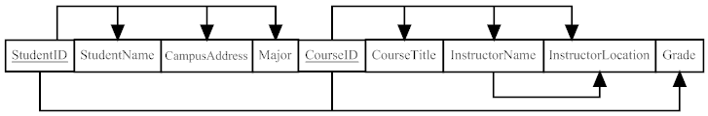

**b. In what normal form is this relation?**

**Ans:** The table given is in 1st Normal Form.

**c. Decompose GRADE REPORT into a set of 3NF relations.**

**Ans:**

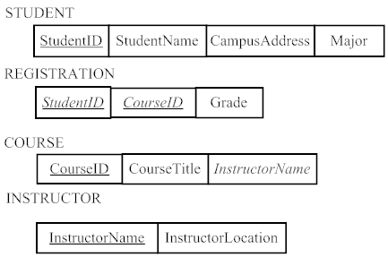

**d. Draw a relational schema for your 3NF relations and show the referential integrity constraints.**

**Ans:**

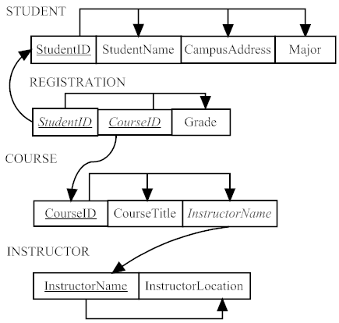

**11. For your answers to the following Problems and Exercises from prior chapters, transform the EER diagrams into a set of relational schemas, diagram the ftmctional dependencies, and convert all the relations to third normal form. a. Chapter 3, Problem and Exercise 15**

**Ans:**

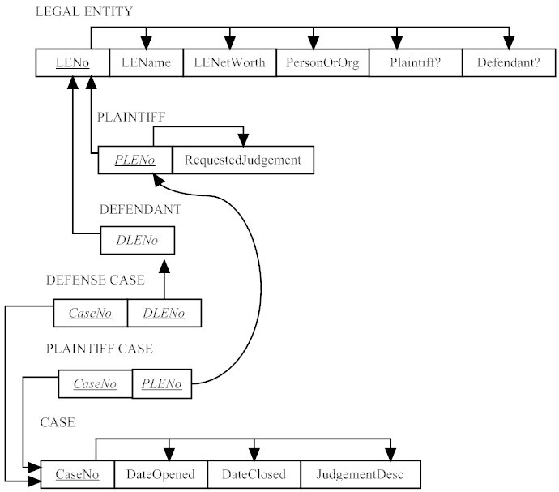

**16. Figure 4-34 shows an EER diagram for Vacation Property Rentals. This organization rents preferred properties in several states. As shown : in the figure, there are tvvo basic types of properties: beach properties and mountain properties.**

**a. Transform the EER diagram to a set of relations and develop a relational schema.**

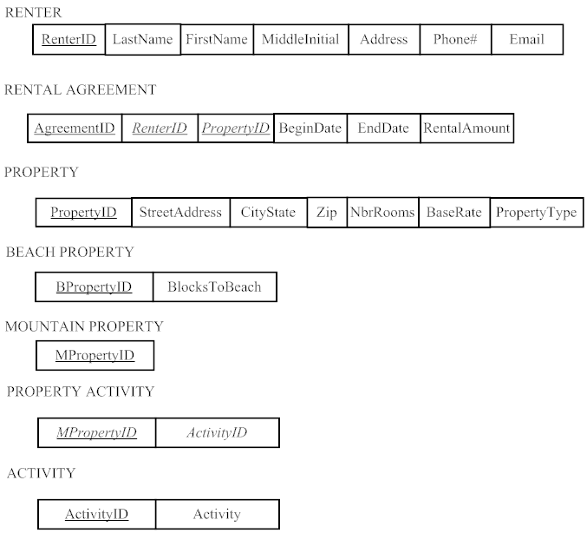

**b. Diagram the functional dependencies and determine the normal form for each relation.**

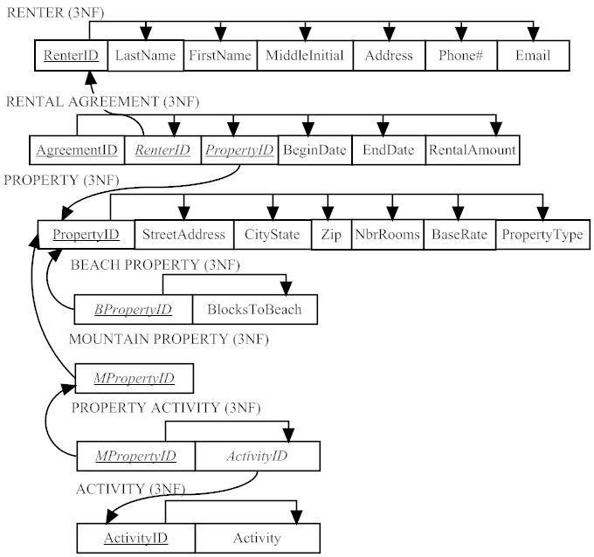

**c. Convert all relations to third normal form, if necessary, and draw a revised relational schema.**

Ans: The given diagram is in 3rd normal form

**d. Suggest an integrity constraint that would ensure that no property is rented twice during the same time interval.**

**Ans:** The property ID can be the integrity constraints.

**18. Figure 4-35 includes an EER diagram describing a car racing league. Transform the diagram into a relational schema that shows referential integrity constraints (see Figure 4-5 for an example of such a schema). In addition, verify that the resulting relations are in 3NF.**

**Ans:**

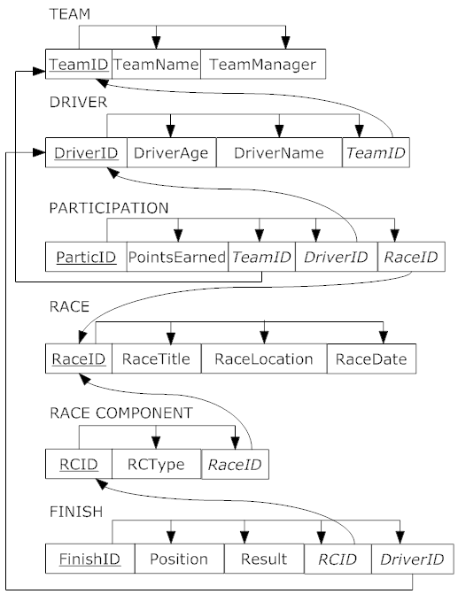

**20. Examine the set of relations in Figure 4-37. What normal form are these in? How do you know this? lf they are in 3NF, convert the relations into an EER diagram. What assumptions did you have to make to answer these questions?**

**Ans:** The given relational schema is in 3NF. We can see this by functional and referential integrity.

